DBMS Mini Project Synopsis

**Hospital Management System**

Name – Hrishikesh Athalye

MIS - 111803154

Class – TY Comp (Sem 5)

Div - 2

**Problem Statement**

Developing a hospital management system in order to effectively manage most aspects of hospitals such as booking appointments, managing patient records and keeping medical history.

**Overview**

Organisations such as hospitals have to deal with a lot of patients regularly and hence a lot of data. Hence it is very important for a hospital to have a DBMS with a frontend that easily allows patients to book appointments and allows doctors or administrators to manage patient data.

For this project I have chosen to build the frontend using ReactJS and JavaScript, backend in Node.js and the database used will be MySQL.

**Functional Requirements**

1. Separate interfaces for patients and doctors. Patients and doctors should have separate logins.
2. Allow patients to book appointments and view/update/cancel them later if necessary, creating free slots for other patients.
3. Allow doctors to cancel appointments.
4. The system should avoid clash of appointments and allow appointments only when a doctor is not already busy or does not have a break.
5. Doctors should be able access patient history and profile, and add to patient history.
6. Doctors should be able to give prescriptions and diagnosis.

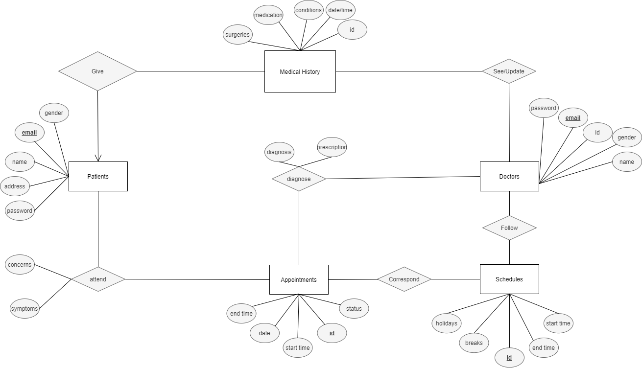**ER Diagram**

**Relational Schemas**

1. Patient

|  |  |  |  |
| --- | --- | --- | --- |
| **Email** | Password | Name | Address |

1. Doctor

|  |  |  |  |  |
| --- | --- | --- | --- | --- |
| **Email** | Gender | Password | Id | Name |

1. Medical History

|  |  |  |  |  |
| --- | --- | --- | --- | --- |
| Surgery | Medication | Condition | Date/Time | **Email** |

1. Appointment

|  |  |  |  |  |
| --- | --- | --- | --- | --- |
| **Id** | Date | Start | End | Status |

1. Schedules

|  |  |  |  |  |
| --- | --- | --- | --- | --- |
| **Id** | Start | End | Holidays | Breaks |

1. Diagnose

|  |  |  |  |
| --- | --- | --- | --- |
| **Appt Id** | Doctor | Diagnosis | Prescription |